**NetMon walkthrough**

# **Index**

Index 1

List of pictures 1

Disclaimer 2

Reconnaissance 2

Initial foothold 3

User flag 3

Privilege escalation 3

Personal comments 5

Appendix A – CVE-2018-9276 5

References 5

# **List of pictures**

Figure 1 - nMap scan results (part 1) 2

Figure 2 - nMap scan results (part 2) 2

Figure 3 - Retriving the user flag 3

Figure 4 - Configuration files found 4

Figure 5 - Database credentials found 4

Figure 6 - Privilege escalation and root flag 5

# **Disclaimer**

I do this box to learn things and challenge myself. I’m not a kind of penetration tester guru who always knows where to look for the right answer. Use it as a guide or support. Remember that it is always better to try it by yourself. All data and information provided on my walkthrough are for informational and educational purpose only. The tutorial and demo provided here is only for those who are willing and curious to know and learn about Ethical Hacking, Security and Penetration Testing.

Just to say: I am not an English native person, so sorry if I did some grammatical and syntax mistakes.

# **Reconnaissance**

The results of an initial nMap scan are the following:

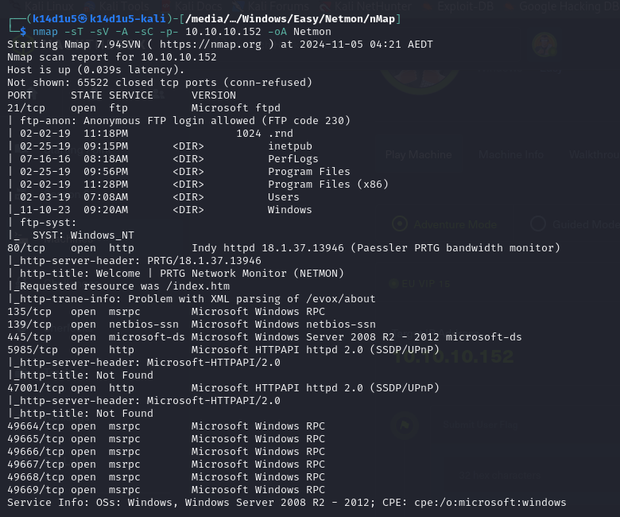

Figure 1 - nMap scan results (part 1)

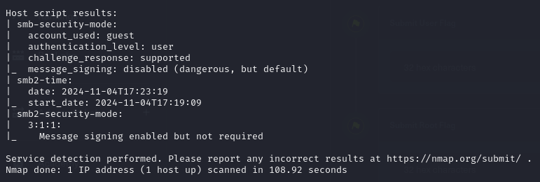

Figure 2 - nMap scan results (part 2)

Open ports are 21, 80, 135, 139, 445, 5985, 47001, 49664, 49665, 49666, 49667, 49668 and 49669. So, this box has FTP service (21), RPC service (135, 47001, 49664, 49665, 49666, 49667, 49668 and 49669), NetBIOS service (139), SMB service (445) and SSDP/UPnP service (47001) enabled. Also, there is web application running on port 80. Lastly, nMap recognized Windows (maybe Windows Server 2008 R2 – 2012) as Operative System.

# **Initial foothold**

Since this box has the FTP service enabled, I tried to perform an anonymous access to it. Luckily, it worked. I accessed in this way both via FileZilla client and via shell.

# **User flag**

One accessed to the box via FTP service, I looked around to find some interesting information and data. While I was navigating the file system, I tried to download the user flag. I was very surprised that it worked and I already retrieved this flag:

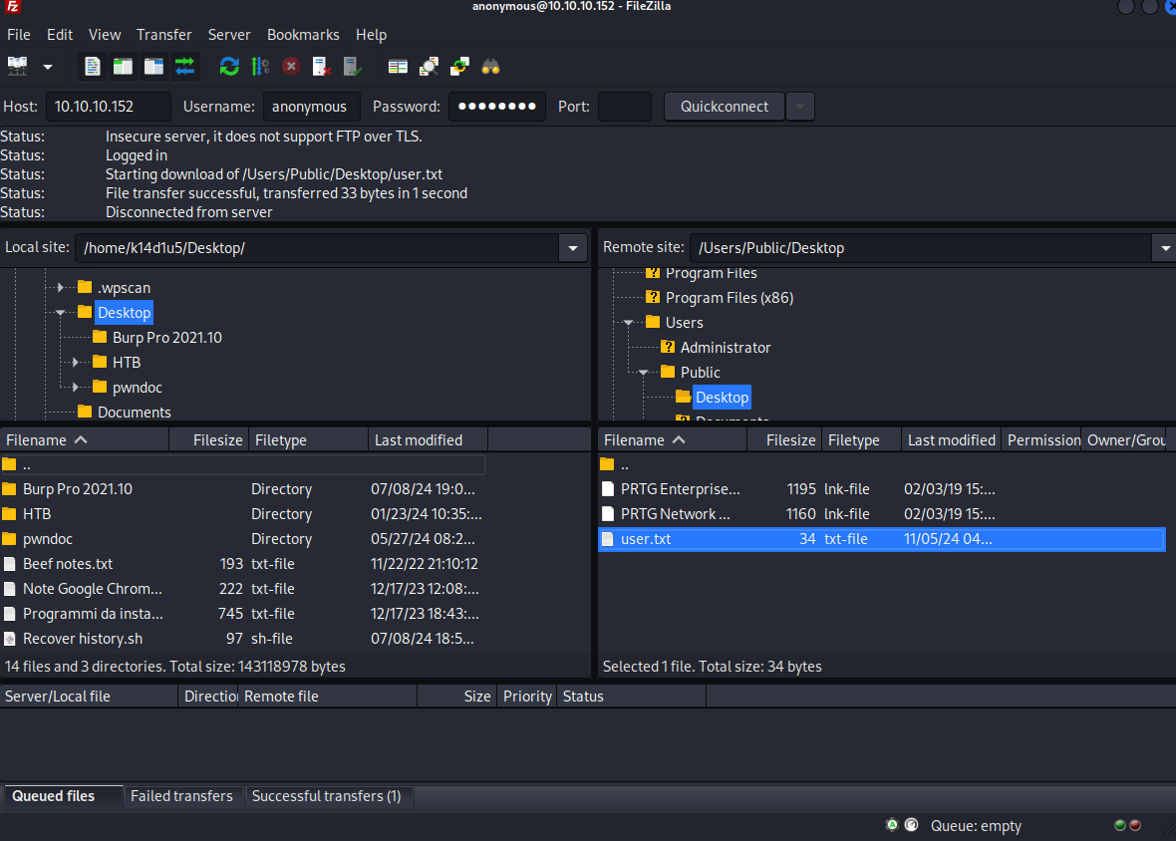

Figure 3 - Retrieving the user flag

# **Privilege escalation**

Of course, at this point I already needed to escalate my privileges, so I still looked for some interesting information on the file system. With a first glance on it, I didn’t find anything. In this case I worked via FileZilla. So, I tried to find some different paths looking for exploit for other services. Even in this case I failed and I was a little struggled on it. After some time, I decided to analyze again the file systema via FTP, but this time I did it using the shell and not the FileZilla client. I was surprised that I was able to find more data in this way. For example, since the web application running on port 80 is PRGT Network Monitor (as I saw by the nMap scan results or browsing the application), I found some data relative to it. Looking for some interesting information on the Internet about this program, I found out that it stores its configuration files in the $C:\backslash ProgramData\backslash Paessler$ path. Here, I found some interesting files:

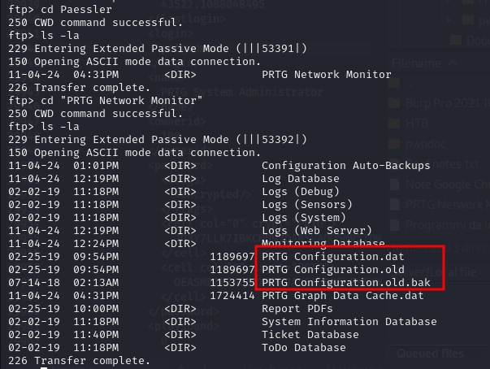

Figure 4 - Configuration files found

In particular, I found a backup configuration file. Inside this file, I luckily found databases credentials:

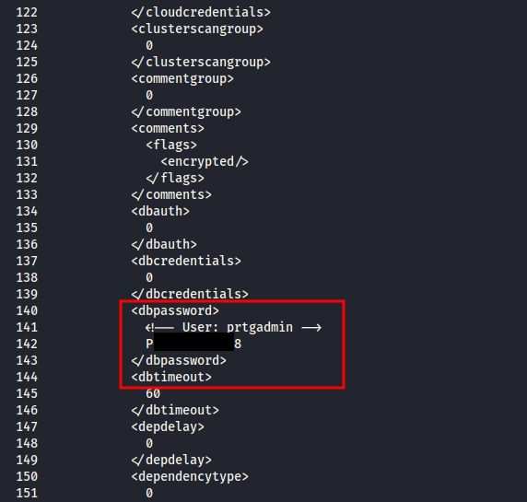

Figure 5 - Database credentials found

I though this password was useful to access to the web portal, but it didn’t work. So, I kept looking for new data and information. After some time, I didn’t find anything else. So, since this box was created in the 2019, I thought I can use the password I found with a little difference to according to the year. I was very surprised it worked and I gained access to the web portal. While I searched for some information about the NETMON application on the Internet, I found an authenticated exploit too. So, this was the time to try it. Luckily, it worked and I obtained a shell as $NT AUTHORITY\backslash SYSTEM$ and I retrieved the root flag:

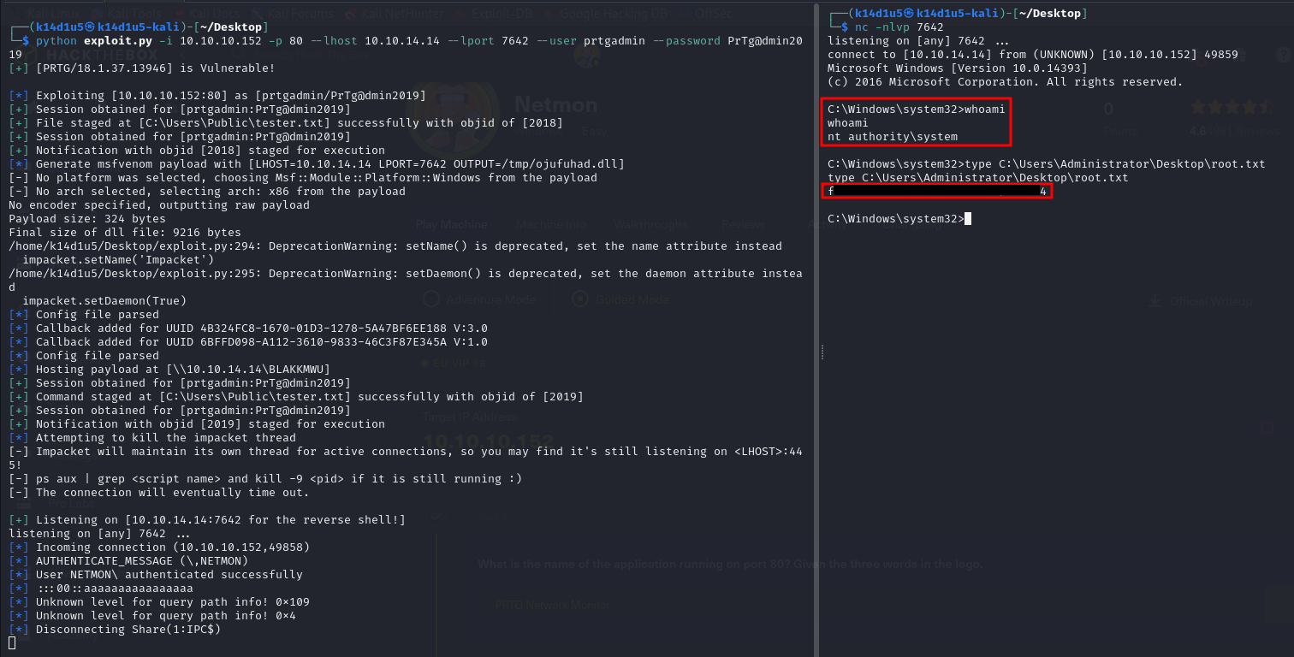

Figure 6 - Privilege escalation and root flag

# **Personal comments**

I didn’t like very much this box honestly. I was very annoying about the NETMON portal’s password because I can understand the rational behind it, but I didn’t think of it because I didn’t consider after several years. In fact, I resolved this box in the 2024 and the box was created 5 years before. This could create a more complicated resolution because you could generate a very long list of passwords starting by the one you found. Maybe it is better to not have a correlation with a temporal information to manipulate when a box is created for some platform as HackTheBox. So, I rated with a higher score the root flag. In particular, I rated easy the user flag and Not too easy the root one.

# **Appendix A – CVE-2018-9276**

Affected by this vulnerability is an unknown function of the component *Web Console*. The manipulation as part of a *Parameter* leads to an OS command injection vulnerability. The product constructs all or part of an OS command using externally-influenced input from an upstream component, but it does not neutralize or incorrectly neutralizes special elements that could modify the intended OS command when it is sent to a downstream component. As an impact it is known to affect confidentiality, integrity, and availability. The attack can be launched remotely. The successful exploitation requires a single authentication. Notifications can be created by an authenticated user and can execute scripts when triggered. Due to a poorly validated input on the script name, it is possible to chain it with a user-supplied command allowing command execution under the context of privileged user. The module uses provided credentials to log in to the web interface, then creates and triggers a malicious notification to perform remote code execution using a PowerShell payload. It may require a few tries to get a shell because notifications are queued up on the server. This vulnerability affects versions prior to 18.2.39.

# **References**

<https://packetstormsecurity.com/files/161183/PRTG-Network-Monitor-Remote-Code-Execution.html> -> CVE-2018-9276 description by PacketStorm Security

<https://cve.mitre.org/cgi-bin/cvename.cgi?name=2018-9276> -> MITRE CVE-2018-9276

<https://vuldb.com/?id.120169> -> CVE-2018-9276 description by Vuldb